Aircraft War

Proposal

By

Xujian Zhang

Florida Tech

CIS 5898 – Projects in Computer Information Systems

For

Dr. David O. LeVan

January 20, 2017

1. Introduction

Aircraft War will be an interesting game that programmed by python. In August 2013, a game about flights war became the most popular game in China. The game depended on a chat software called “Wechat” and had above 200 million players. However, in my opinion, the flights game wasn’t perfect: you just had one life that one hit from enemies will cause game over, you just can use one kind of bullets and you could only play the game on mobile device. Also, the game just has a same difficult. It’s kind of boring when you play a lot of time. Limit playing method caused limit happiness and low ability of earning money. Thus, I prefer to develop an Aircraft War game to have more fun and challenging. The Aircraft War will have multiple lives, three kinds of bullet, multiple enemies and you could play the game on your own laptop.

As the classic game Tetris, you could see your highest score when you are game over and you could see your current score anytime. Also, Aircraft War has the same function. You could challenge yourself step by step. The easy way to control and the high rhythm will provide a short but joyful time when you play it.

The game will also use MySQL as the database. When players play the game, the database will collect the count of normal bullets and super bullets. Also players could find how much time they spend on each game. Players will see them not only on the game over screen, but also on the pause screen.

1. Project Solution

First step, in order to initiate the game, the game will load background picture and music. Then, on the background picture, the game will generate player flight, enemy flights, normal bullet and super bullet. The game has a pause button. Players could pause the game anytime they want. Also, players will see how many lives they have and how many super bullets they could use. During the play time, the game will provide extra supply box to give players more super bullets.

Super bullets are different from normal bullets. Players can destroy all the enemies at same time by using super bullet. Normal bullets will be used automatically that players could concentrate on controlling their plane to avoid enemies.

Depending on player’s technique, the difficulty of the game will be changed from easy to hard. Hard means player will face more enemies at same time. It’s a good way to make players feel more interesting during playing Aircraft War.

The game will also collect the player’s data such as how much normal bullets they used or how much time they have spent. Players could see them on the game over screen or pause screen.

Main flowchart:

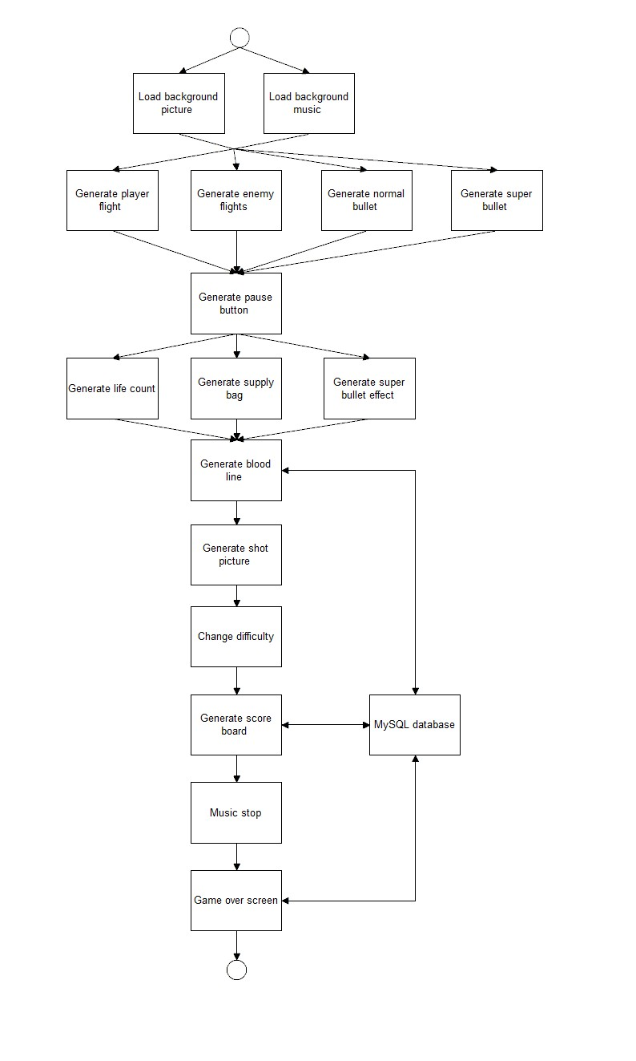

Player’s aircraft will be destroyed through touching enemies. If players don’t have enough lives, their game will be end.

Flowchart of player’s aircraft:

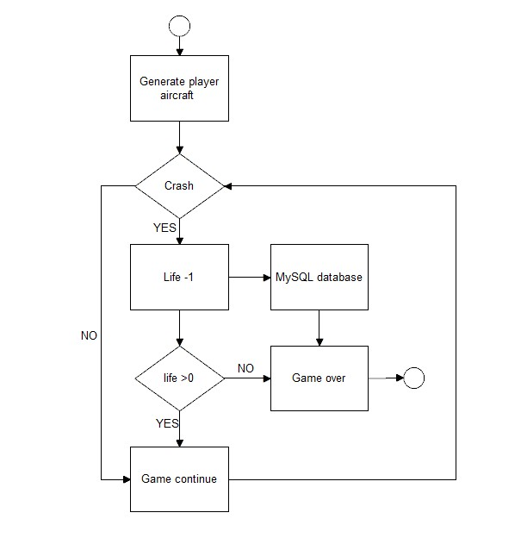

Normal bullet will shoot automatically. When a bullet shoot an enemy successfully, a blood line will be showed on the top of the enemy. Then player could know how much blood the enemy remains. MySQL database will collect how much normal bullet the player used in each game.

Flowchart of bullet:

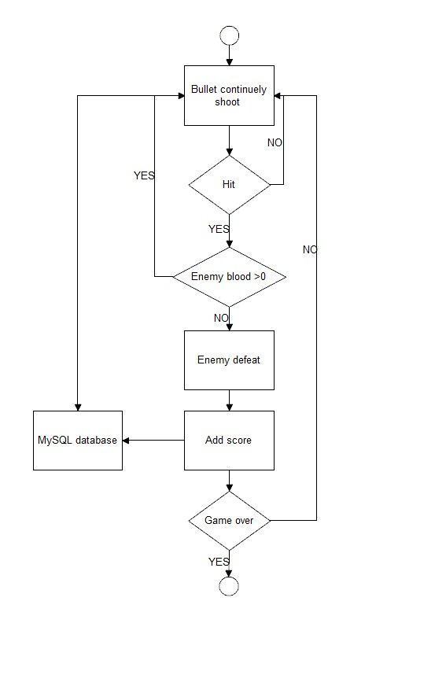

The game will generate enemies from the top of the screen. They will have 3 different kinds of enemies: small, medium and large aircraft. Different size has different blood capacity. Also, different difficulty has different count of enemies.

Flowchart of enemy aircraft:

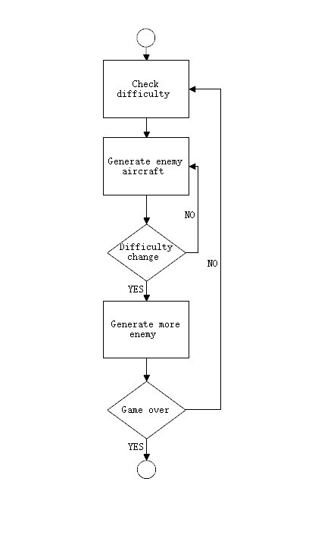

Pause will be an important function. If players have something to do but they have gotten a high score, they could pause the game and continue anytime. After they press the pause button, the pause screen will also show the current data of the game such as bullets count or game time.

Flowchart of pause:

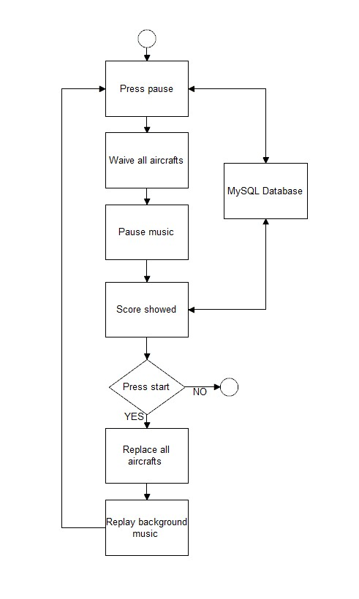

Super bullet is different from normal bullet. Normal bullet just can go straight and attack the enemies in the same line. However, super bullet could destroy all the enemies no matter where the players are. Normal bullet is infinity but super bullet is limit. One way to get more supper bullet is to carry the supply box.

Flowchart of super bullet:

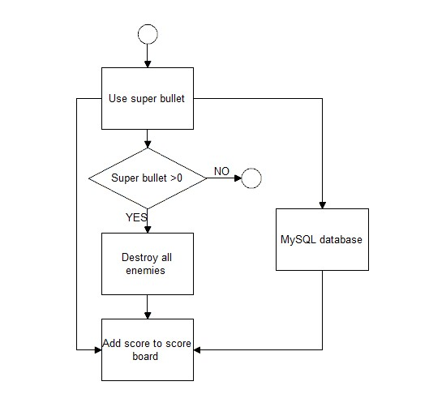

When players are playing Aircraft War and destroying enemies, they will receive score from each enemy. Different enemy has different score. When players finish one game, the game will return a score. You could see the score and the highest score.

Flowchart of score board:

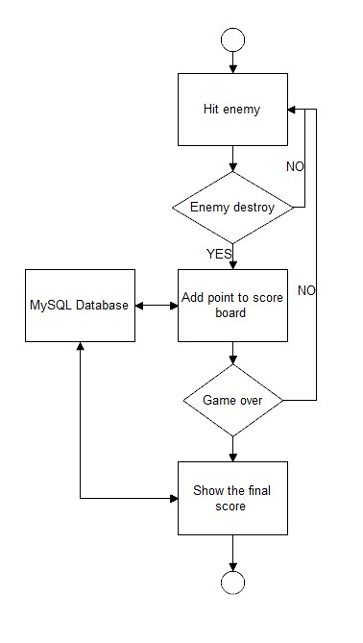

During game time, player will receive supply box. One box means one super bullet or double normal bullets. However, supply box will drop from anywhere of the top of screen. If players want more super bullet, they need to catch them.

Flowchart of supply box:

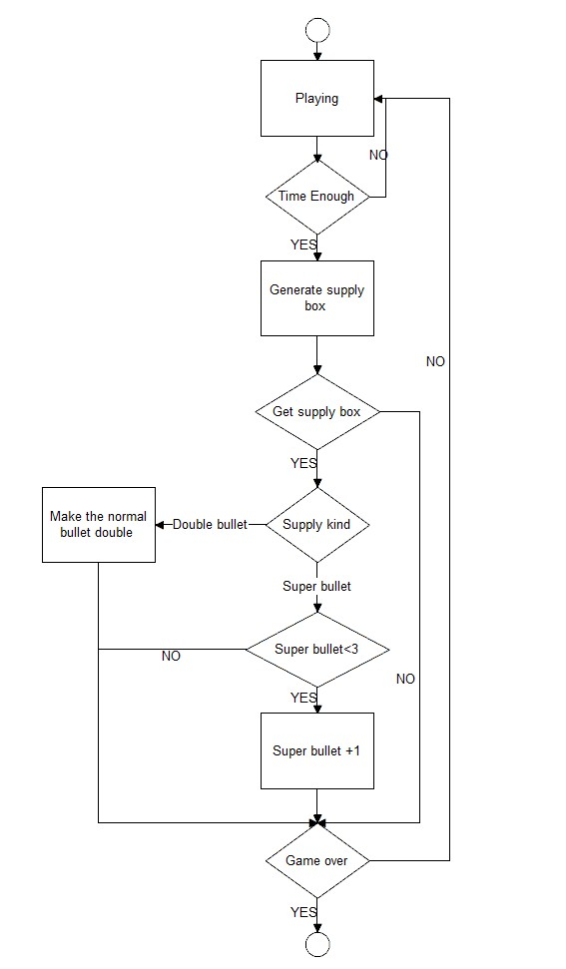

1. Implementation

Aircraft War will use python as programming language and it runs on Windows 7, 8 & 10. It used the packages of “pygame”. The main program wrote by the official tool of python (<https://www.python.org/>): IDLE (Python 3.6 32-bit). “Pygame is a python wrapper for SDL. What this means is that, using pygame, you can write games or other multimedia applications in Python that will run unaltered on any of SDL’s supported platforms (Windows, UNIX, Mac and others). The most important part of pygame is the surface. Just think of a surface as a blank piece of paper. You can do a lot of things with a surface – you can draw lines on it, fill parts of it with color, copy images to and from it, and set or read individual pixel colors on it. A surface can be any size (within reason) and you can have as many of them as you like (again, within reason). One surface is special – the one you create with pygame.display.set_mode (). This ‘display surface’ represents the screen; whatever you do to it will appear on the user’s screen. You can only have one of these – that’s an SDL limitation, not a pygame one.” (pygame documentation, 2012)

The game will also use MySQL as the database. During the game playing time, the database of the game will record the following attribution continually: playing time, total normal bullet used, total supper bullet used and total score. Player could check them anytime from pause screen. Also, they will be showed on game over screen.

The MySQL database server provides the ultimate in scalability, sporting the capacity to handle deeply embedded applications with a footprint of only 1MB to running massive data warehouses holding terabytes of information. Platform flexibility is a stalwart feature of MySQL with all flavors of Linux, UNIX, and Windows being supported. And, of course, the open source nature of MySQL allows complete customization for those wanting to add unique requirements to the database server. (Top Reasons to Use MySQL, 2016)

1. Details of game developing

Considering developing a complete game, Aircraft War need to maintain 4 parts of it: beginning part, playing part, pause part and ending part.

From beginning, Aircraft War need to initiate all the things in background: music and picture.

In the playing part, controlling the count of enemies, difficulty changing, supply box providing… need to be concerned.

In the pause part, player will see the statistics of current game. Also, the background music and any icons need to be modified.

In the end, player will know the final statistics of this game and they could choose close or play again.

Consequently, as an interesting game, I need to consider more about the difficulty changing and supply box providing. After assembling all parts of the game, Aircraft War should be tested well.

At first I need to generate a playing field with a suit background size. I choose 480*700 because it depends on the background picture. After that, I load all music resources for the game and set the volume.

Next step, I need to generate player’s plane. If I want to generate player’s plane, I will initiate it in the middle bottom of the screen. Next, when player move their plane, I need to make sure the plane won’t go outside of the screen. So I limit the plane by four direction: up, down, left and right. Especially down, you need keep enough space for deck. So I remain 60 height. At this time I have considered that how can I control player’s plane.

My habit is using up, down, left, right or w, a, s, d to control plane. So I write the method to check player’s operation.

Then, I considered that how to generate enemy planes. I design that there are three different enemy. So there must have 3 classes used to generate them. In each class, I will set several images used to switch pictures, set position, set speed, set energy, set move and reset it.

After create classes, I begin to create a whole group with 3 different enemy and it used to detect collision. Then, I define 3 functions to add enemy in group.

Because there are 3 different enemies, I need to choose which one could generate first. For enjoying game, I think I need to draw big enemy at first because if I draw small enemy at first, it may be covered by middle or big enemies.

Then, I check the status of enemies. If Boolean is true, make the enemy move and switch the images that used to make it looks in progress. Else if Boolean is false, it means the enemy is destroyed and also switch photos. Then I reset the enemy. During an enemy destroyed, a background music will play. Again, for making destroy looks in progress, I also prepare several pictures for switching.

After draw enemies, I want to check collision. If player’s plane touches enemies, the life will decrease and reset player’s plane. To check collision, I used “pygame.sprite.spritecollide”. It’s very useful that you could check collision by images’ available size.

Next I considered to design bullet. At first I need to design 2 kinds of bullet: one line bullet and double bullet. For normal bullet, I need to set proper speed and number to make sure the balance of difficulty and fun. Then I need to check if bullets hit enemy or not. After that I set energy for middle and big enemy. Different energy means different number of bullets could destroy it. Then I want to add a bar for every middle and big enemy by showing remain energy.

For showing energy, I draw two line on the top of enemy: one is black, another is green. If the enemy is hit, change the green line. If energy is low, change the green line to red.

Then I set score system during playing time on the top left of screen. I define that every big enemy is 100 points, middle enemy is 60 points and small enemy is 10 points.

Next I begin to develop pause function. If player press pause button, the button will change to resume button and the whole game will pause. When you press pause, I use a background picture to cover all planes and bullet on the screen. Player couldn’t use pause button to low the difficulty because he couldn’t see any situation when the game pause.

Then I considered to modify the difficulty of the game. I want to modify 2 parts of the game: number and speed of enemies. And it depends on player’s score. I set 5 levels. Every level will modify the number of enemies and the speed of small enemies. Also, when level changed, the game will play a sound as a signal.

Next I will draw the super bullet on the bottom left of the screen and show remain number of bullet. Then I need to check if player press space key or not because I set the key for using super bullet. When player press space, all enemy will be destroyed and the score will be added.

Then I’m going to design supply bag. There are two kinds of supply bag: one is supper bullet and the other is double bullet. The supply bag will come from a random place on the top of screen. The supply bag will be slower than planes for easy catching. Supply bag will be provided every 30 second and it would be a super bullet bag or double bullet bag. When supply bag provided, it should have a sound played for reminding player. Also, if player supper bullet’s number less than 3, the number add 1. If player get the double bullet supply bag, he will have 18 second to use it. If the game pauses, the supply bag provide will be pause.

Next I will develop the part that give player multiple chance, or more lives. I will show it on the bottom right of screen. Player will see some small planes. One plane means one more life. Also, every time player’s plane reset, their plane won’t get any hurt in 3 second.

When there is no life remain, the game will be over. Then player could choice restart game or quit. Also, player will see all data during game playing.

For score board and database design, I prepare to provide the following data: destroy number of small enemy, middle enemy, big enemy; supply bag number of supper bullet and double bullet; total score and total playing time; super bullet used. Player will see score, small enemy, middle enemy and big enemy during playing game. And he will see all the data within time, super bullet bag accept, double bullet bag accept, normal bullet used, double bullet used, and super bullet used when player game over.

User manual

1. Schedule

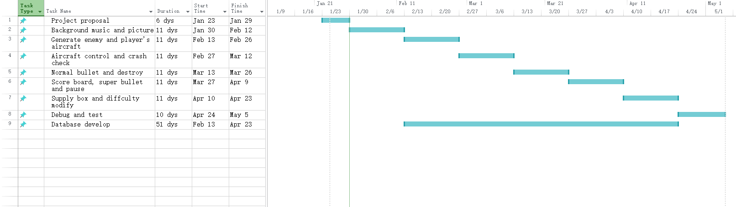

1. References

pygame documentation (2012). https://www.pygame.org/docs/tut/newbieguide.html

Top Reasons to Use MySQL (2016). https://www.mysql.com/why-mysql/topreasons.html